Regulatory Committee
Meeting to be held on 15th September 2021

Part I

Electoral Division affected:
South Ribble West

Wildlife and Countryside Act 1981
Definitive Map Modification Order Investigation
Investigation into public rights from Mill Hill Farm to Haunders Lane, Much Hoole (Annex ‘A’ refers)

Contact for further information quoting the reference number 804-625:
Simon Moore, 01772 531280, Paralegal Officer, County Secretary and Solicitors Group, Simon.Moore@lancashire.gov.uk
Jayne Elliott, 01772 537663, Public Rights of Way Definitive Map Officer, Planning and Environment Group, jayne.elliott@lancashire.gov.uk

Executive Summary

Investigation into an application to upgrade a footpath and add a bridleway on the Definitive Map and Statement of Public Rights of Way from Mill Hill Farm to Hannings Farm, Haunders Lane, Much Hoole.

Recommendation

That the application for the addition of a bridleway and upgrading of part of

Footpath 7-8-FP3 be accepted with modification to recognise carriageway rights.

That an Order(s) be made pursuant to Section 53 (2)(b)) and Section 53

(3)(c)(i) and (ii) of the Wildlife and Countryside Act 1981 to add a restricted byway and upgrade a footpath to restricted byway on the Definitive Map and Statement of Public Rights of Way as shown on Committee Plan between points A-B-C-D-E-F-G.

That being satisfied that the higher test for confirmation can be met the

Order(s) be promoted to confirmation.

Background

An application under Schedule 14 of the Wildlife and Countryside Act 1981 has been received to record a bridleway from Mill Hill Farm off Haunders Lane, Much Hoole, through Marsh Farm to Hannings Farm.

The county council is required by law to investigate the evidence and make a decision based on that evidence as to whether a public right of way exists, and if so its status. Section 53(3)(b) and (c) of the Wildlife and Countryside Act 1981 set out the tests that need to be met when reaching a decision; also current Case Law needs to be applied.

An order will only be made to add a public right of way to the Definitive Map and Statement if the evidence shows that:

- A right of way “subsists” or is “reasonably alleged to subsist”

An order for upgrading or downgrading a way shown on the Definitive Map and Statement will only be made if the evidence shows that:

- "it ought to be there shown as a highway of a different description"

An order for adding a way to or upgrading a way shown on the Definitive Map and Statement will be made if the evidence shows that:

- “the expiration… of any period such that the enjoyment by the public…raises a presumption that the way has been dedicated as a public path or restricted byway”

When considering evidence, if it is shown that a highway existed then highway rights continue to exist (“once a highway, always a highway”) even if a route has since become disused or obstructed unless a legal order stopping up or diverting the rights has been made. Section 53 of the Wildlife and Countryside Act 1981 makes it clear that considerations such as suitability, the security of properties and the wishes of adjacent landowners cannot be considered. The Planning Inspectorate’s website also gives guidance about the interpretation of evidence.

The county council’s decision will be based on the interpretation of the evidence discovered by officers and documents and other evidence supplied by the applicant, landowners, consultees and other interested parties produced to the County Council before the date of the decision. Each piece of evidence will be tested and the evidence overall weighed on the balance of probabilities. It is possible that the council’s decision may be different from the status given in any original application. The decision may be that the routes have public rights as a footpath, bridleway, restricted byway or byway open to all traffic, or that no such right of way exists. The decision may also be that the routes to be added or deleted vary in length or location from those that were originally considered.

Consultations

South Ribble Borough Council

South Ribble Borough Council was consulted but no response was received.

Much Hoole Parish Council

Much Hoole Parish Council was consulted but no response was received.

Advice

Head of Service – Planning and Environment

Points annotated on the attached Committee plan.

Point | Grid Reference (SD) | Description
A | 4556 2215 | Open junction with U3142, known as Mill Hill Farm
B | 4554 2226 | Point at which Footpath 7-8-FP3 joins the track
C | 4549 2241 | Track peters out (C-D has been ploughed)
D | 4553 2242 | Track becomes discernible as field edge strip (D-E)
E | 4547 2254 | Application route crosses a culvert
F | 4540 2258 | Bend in route as it passes Marsh Farm
G | 4550 2274 | Unmarked point at which 7-8-FP3 terminates at junction with Haunders Lane (U1314) adjacent to Hannings Farm

Description of Route

A site inspection was carried out in April 2021.

n.b. Reference to public rights of way shown on the Definitive Map and Statement are generally given in the form 7-8-FP3 or Footpath Much Hoole 3 but below it is referenced in the abbreviated form 'Footpath 3' since the only recorded public right of way referred to is Footpath Much Hoole 3.

The application route commences at the northern end of the unclassified county road (UCR) referenced U3142, known as Mill Hill Farm at point A on the committee plan adjacent to a field boundary/ditch to the west.

The U3142 leading to point A is an unsurfaced compacted earth track used predominantly by farm machinery to access adjacent fields. At point A there is no discernible difference between the U3142 and the start of the application route.

Beyond point A the application route continues as a substantial track through to point B where Footpath 3 joins the track from the east. Signs indicating the presence of ground nesting birds and the requirement to keep to marked footpaths were located at this point.

Beyond point B the route continues as a substantial farm track through to point C where the track ends and the route continues around a ninety degree bend along the edge of a recently ploughed and harrowed field in an easterly direction for approximately 40 metres to point D where the route then turns ninety degrees again to continue in a north north westerly direction along the field edge through point E and continues as a 3-3.5 metre wide grass track between farm buildings to Marsh Farm (point F). From point F the route continues along a compacted earth/stone surfaced track through to Hannings Farm where (point G) the application route ends at the unmarked junction with the road recorded as U1314 Haunders Lane.

The total length of the route is 810 metres.

Map and Documentary Evidence

A variety of maps, plans and other documents were examined to discover when the route came into being, and to try to determine what its status may be.

Document Title | Date | Brief Description of Document & Nature of Evidence
Yates’ Map  of Lancashire | 1786 | Small scale commercial map. Such maps were on sale to the public and hence to be of use to their customers the routes shown had to be available for the public to use. However, they were privately produced without a known system of consultation or checking. Limitations of scale also limited the routes that could be shown.
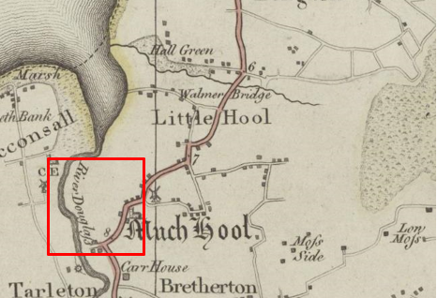
Observations |  | The application route is not shown.
Investigating Officer's Comments |  | The application route probably did not exist at the time or if it did exist, was not considered to be a substantial public vehicular route by Yates. If it did exist it would have been very unlikely for a route considered to be a footpath or bridleway to be shown on such a small-scale map.
Cary's Map of Lancashire | 1787 | John Cary was described as 'the most representative, able and prolific of English cartographers'. He was as busy a publisher as he was a cartographer and engraver, and until his death in 1835 published a constant flow of atlases, maps, road maps, canal plans, globes and geological surveys. He set new high standards of engraving and map design and in 1787 he published a 'New and Correct English Atlas' containing 46 maps which was re-issued ten times until 1831.  In 1794 the Postmaster General commissioned Cary to survey the main roads of Great Britain and his information on roads may be viewed with above average confidence.
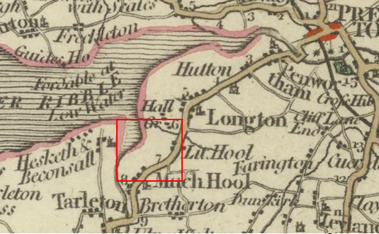
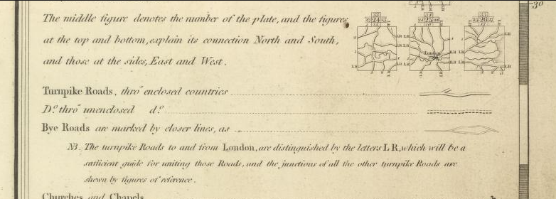
Observations |  | The application route is not shown.
Investigating Officer's Comments |  | The application route probably did not exist at the time or if it did exist, was not considered to be a substantial public vehicular route. If it did exist it would have been very unlikely for a route considered to be a footpath or bridleway to be shown on such a small-scale map.
Greenwood’s Map of Lancashire | 1818 | Small-scale commercial map. In contrast to other map makers of the era Greenwood stated in the legend that this map showed private as well as public roads and the two were not differentiated between within the key panel.
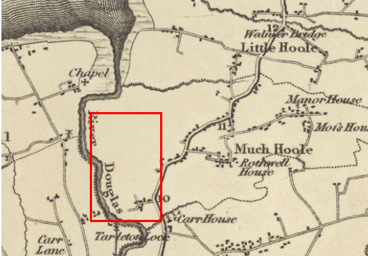
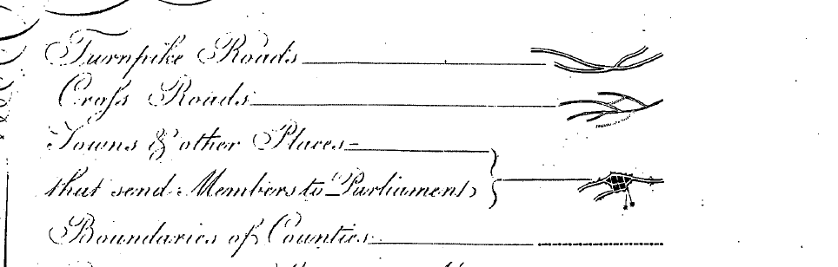
Observations |  | The start of the U3142 appears to be shown but the application route is not shown.
Investigating Officer's Comments |  | The application route probably did not exist as a through route at the time or if it did exist, was not considered to be a substantial public vehicular route by Greenwood.
Hennet's Map of Lancashire | 1830 | Small-scale commercial map. In 1830 Henry Teesdale of London published George Hennet's Map of Lancashire surveyed in 1828-1829 at a scale of 7½ inches to 1 mile. Hennet's finer hachuring was no more successful than Greenwood's in portraying Lancashire's hills and valleys but his mapping of the county's communications network was generally considered to be the clearest and most helpful that had yet been achieved.
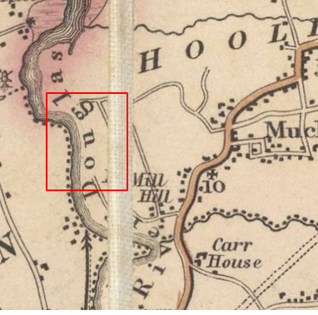
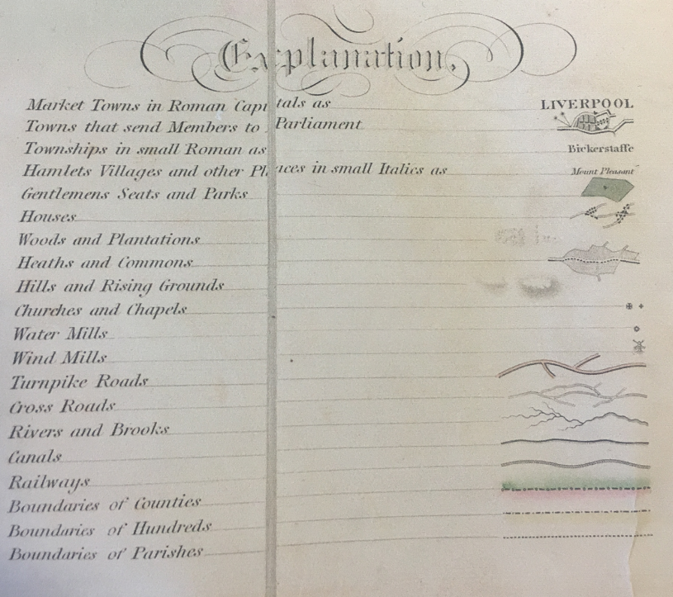
Observations |  | The area crossed by the application route was partially on the fold of the map but despite this a route can be clearly seen leaving Haunders Lane consistent with the U3142 through to the approximate position of point A. From there through to the approximate position of point G the application route is not shown although Haunders Lane is shown. The word 'Douglas' was written on the map over the area through which the application route would have run.
Investigating Officer's Comments |  | The routes connecting to the application route at point A and point G are both shown on the map as cross roads and existed in 1830. It is not fully known what is meant by this term but as the only other category of 'road' shown on the map are turnpike roads, it is possible that a cross road was regarded as either a public minor cart road or a bridleway (as suggested by the judge in Hollins v Oldham).  Hollins v Oldham Manchester High Court (1995) [C94/0205] Judge Howarth examined various maps from 1777-1830 including Greenwoods, Bryants and Burdetts. Maps of this type, which showed cross roads and turnpikes, were maps for the benefit of wealthy people and were very expensive. There was “no point showing a road to a purchaser if he did not have the right to use it.”  The application route is not shown on the map which may have been that it did not exist or that if it did exist it was not considered to be part of a public vehicular through route however this could have been because of the labelling of the River Douglas at this point.
Canal and Railway Acts |  | Canals and railways were the vital infrastructure for a modernising economy and hence, like motorways and high-speed rail links today, legislation enabled these to be built by compulsion where agreement couldn't be reached. It was important to get the details right by making provision for any public rights of way to avoid objections but not to provide expensive crossings unless they really were public rights of way. This information is also often available for proposed canals and railways which were never built.
Observations |  | The land crossed by the application route was not affected by any existing or proposed canals.
Investigating Officer's Comments |  | No inference can be drawn with regards to the existence of public rights.
Tithe Map and Tithe Award or Apportionment | 1841 | Maps and other documents were produced under the Tithe Commutation Act of 1836 to record land capable of producing a crop and what each landowner should pay in lieu of tithes to the church. The maps are usually detailed large scale maps of a parish and while they were not produced specifically to show roads or public rights of way, the maps do show roads quite accurately and can provide useful supporting evidence (in conjunction with the written tithe award) and additional information from which the status of ways may be inferred.
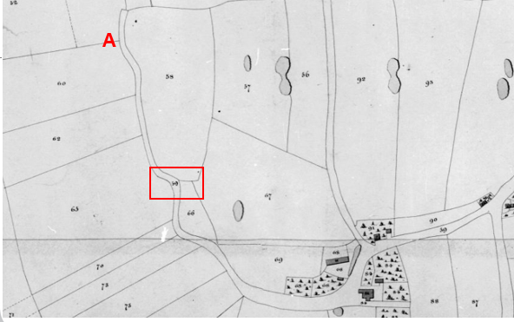
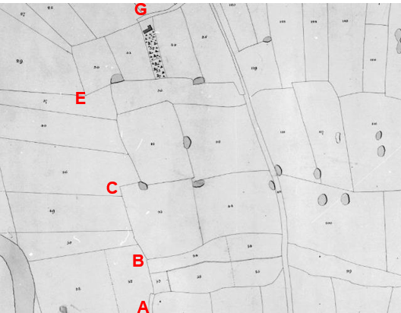
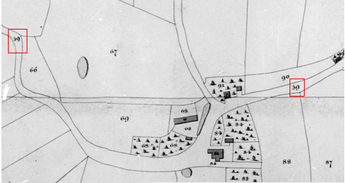
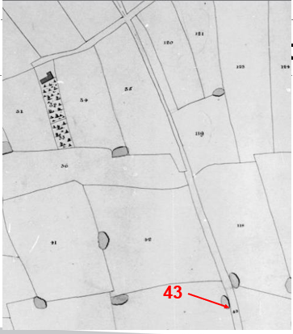
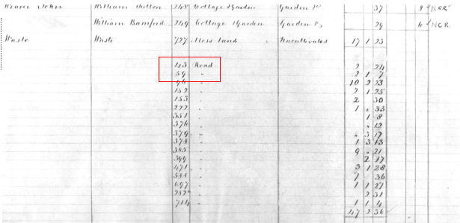
Observations |  | The U3142 from Haunders Lane is shown as a bounded route passing through point A to part way between point A and point B and is numbered as plot 59 on the Map. The Tithe Award lists plot 59 as 'Road' for which no land owner or occupier is listed and no tithes are payable. Haunders Lane is also shown on the Tithe Map with the number 43 and is listed as 'Road' in the Tithe Award and appears to include that part of Haunders Lane which provides access to Hannings Farm and to the application route at point J.  Marsh Farm is not shown on the Tithe Map and the application route from part way between point A and point B through to just west of point G is not shown.  Both the U3142 and Haunders Lane are included in a list at the end of the Award of 'Roads'. The list comprises 17 routes which are labelled at the end of the Award as 'Road'. Looking more closely at the 17 routes listed, 12 of those routes are now recorded as vehicular highways for all or most, or in 1 case some, of their length, 2 routes (including the application route) are subject to applications to be upgraded, 1 is recorded as footpath and 2 have no recorded public status and of which there is no physical trace.
Investigating Officer's Comments |  | The application route from point A through to midway between point A and point B existed in 1841 and was considered to be part of the public vehicular highway network at that time.  The remainder of the application route did not exist as an enclosed way in 1841.
Inclosure Act Award and Maps |  | Inclosure Awards are legal documents made under private acts of Parliament or general acts (post 1801) for reforming medieval farming practices, and also enabled new rights of way layouts in a parish to be made. They can provide conclusive evidence of status.
Observations |  | There is no Inclosure Award for the land crossed by the application route.
Investigating Officer's Comments |  | No inference can be drawn with regards to the existence of public rights.
Cassini Historical Map  Old Series  Preston & Blackpool  Sheet 102 | 1842-1852 | The Cassini publishing company produced maps based on Ordnance Survey mapping. These maps have been enlarged and reproduced to match the modern day 1:50,000 OS Landranger Maps and are readily available to purchase.
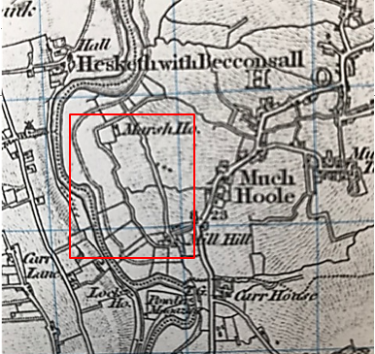

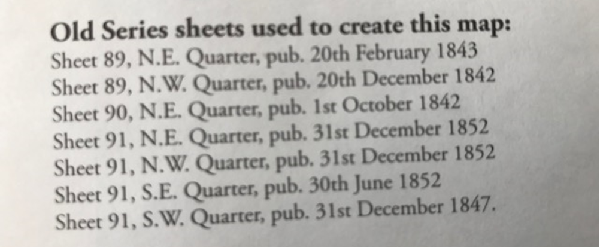
Observations |  | The full length of the application route is shown as part of a substantial bounded through route. Hannings Farm is labelled as Marsh House.
Investigating Officer's Comments |  | The original scale of the map (1 inch to the mile) means that only the more significant routes are generally shown. The early (first edition) OS maps on which the Cassini Old Series maps were based were originally produced for military purposes. The inclusion of the route on those maps suggests that a substantial route existed which probably could have been used by all traffic but we do not know if that use was public, private or military.
6 Inch Ordnance Survey (OS) Map  Sheet 68 | 1848 | The earliest Ordnance Survey 6 inch map for this area surveyed in 1844-45 and published in 1848.
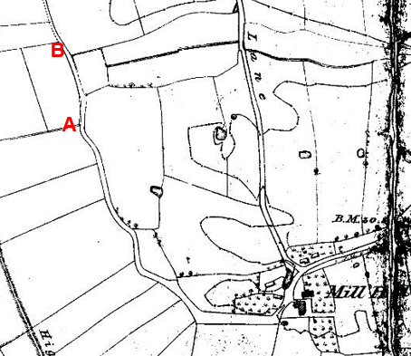
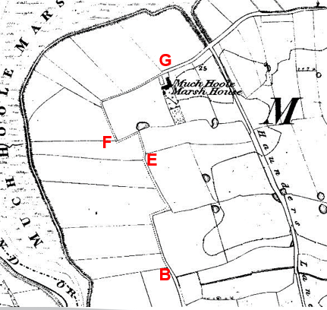
Observations |  | The full length of the application route is shown as part of a longer route. From point A to point B the route is shown largely bounded on both sides. Beyond point B through to point G the route is shown following the field edge bounded on one side and open to the fields it passes through on the other. Marsh Farm is not shown and Hannings Farm is shown and labelled as being Much Hoole Marsh House.
Investigating Officer's Comments |  | The full length of the application route existed as a through route in 1844-45 and appeared to be capable of being used. The fact that it was a through route suggests it was for traffic travelling from one farm to the next, not simply an occupation road.
25 Inch OS Map  LXVIII.14 | 1893 | The earliest OS map at a scale of 25 inch to the mile. Surveyed in 1891-1892 and published in 1893.
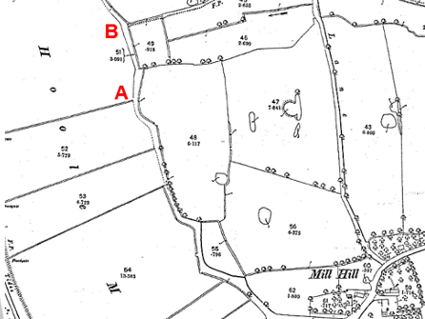
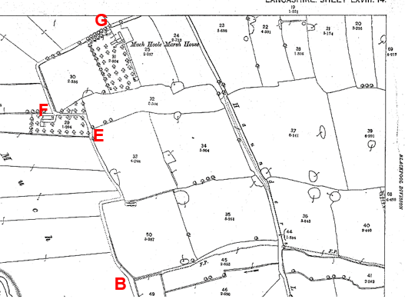
Observations |  | The full length of the application route is shown largely unenclosed.  Between point E and point F the route is shown as an enclosed route through woodland and buildings are shown in the location of the modern day property known as Marsh Farm. Hannings Farm is shown labelled as Much Hoole Marsh House and from point F through to point G and then continuing along Haunders Lane the route is shown with a thickened line along the south and east side.  One parcel number is shown near point B – parcel number 51 acreage 3.091 relates to the full length of the application route and also to the U3142 south of point A and Haunders Lane extending east from Mill Hill Farm through to the edge of the map sheet and also to Haunders Lane east of point G through to the edge of the map sheet.
Investigating Officer's Comments |  | The full length of the application route existed in 1891-92 as a substantial through route which appeared to be capable of being used on horseback and with horse drawn vehicles at that time. It provided access to and past a number of properties located along it.  The Planning Inspectorate Consistency Guide states "Public roads depicted on 1:2500 maps will invariably have a dedicated parcel number and acreage." However, it goes on to say that this is far from conclusive evidence of highway status. The fact that the route is given one parcel number which appears to extend beyond both 'ends' of the application route and along routes now recorded as public vehicular highways does suggest however that the route was seen as a through route and not as piecemeal sections.  Shading and colouring were often used to show the administrative status of roads on 25 inch maps prepared between 1884 and 1912. The application route is shown with a thickened line from point F to point G. The Ordnance Survey specified that all metalled public roads for wheeled traffic kept in good repair by the highway authority were to be shaded and shown with thickened lines on the south and east sides of the road. ‘Good repair’ meant that it should be possible to drive carriages and light carts over then at a trot so the fact that part of the route is shown in this way is consistent with how it was included on early small-scale OS maps and indicated that the route was probably capable of being used by the public with vehicles at that time. The fact that the middle section of the route was not shown with a thickened line may indicate that as a field edge track bounded largely on just one side that this section was perhaps less well maintained or that the surface varied seasonally.
1 inch OS Map  Sheet 75 | 1896 | 1 inch OS Revised New Series map Published 1896.
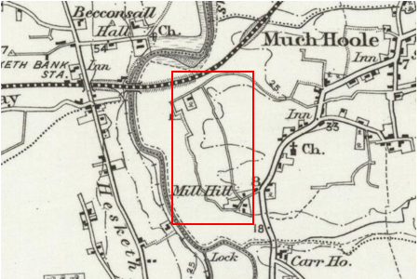

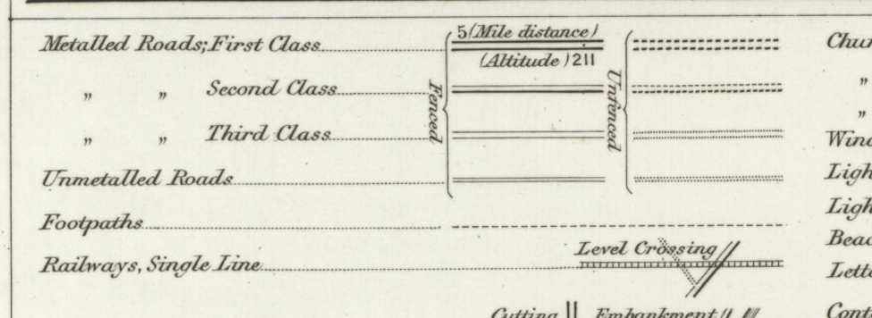
Observations |  | The application route is shown as part of a defined through route shown consistent with how Haunders Lane is shown as a third class or unmetalled road.
Investigating Officer's Comments |  | This is a map surveyed to show what existed physically. The existence of this substantial road does not in itself show public rights but is consistent with public rights supported by other evidence.  By the late 1800s the small scale 1 inch OS maps had started to gain a significant market being the travelling public so the inclusion of most of the route on this map is suggestive of a through route that was capable of being used at least on horseback and possibly by horse and carts.
25 inch OS Map  LXVIII.14 | 1911 | Further edition of the 25 inch map surveyed in 1891-1892, revised in 1909 and published in 1911.
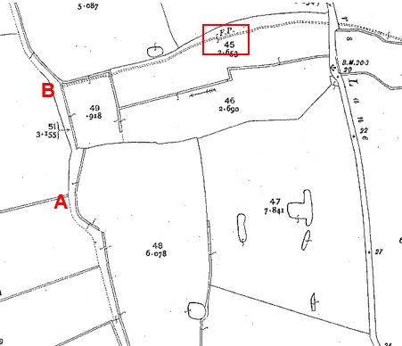
Observations |  | The full length of the application route is shown in the same way as it is shown on the earlier edition of the 25 inch map. A route annotated as a footpath (FP) consistent with the route of Footpath 3 is shown joining the application route at point B. The application route itself is not annotated as a footpath.
Investigating Officer's Comments |  | The application route existed as a part of a substantial through route in 1909 and appeared capable of being used.
Bartholomew half inch Mapping | 1902-1906 | The publication of Bartholomew's half inch maps for England and Wales began in 1897 and continued with periodic revisions until 1975. The maps were very popular with the public and sold in their millions, due largely to their accurate road classification and the use of layer colouring to depict contours. The maps were produced primarily for the purpose of driving and cycling and the firm was in competition with the Ordnance Survey, from whose maps Bartholomew's were reduced. An unpublished Ordnance Survey report dated 1914 acknowledged that the road classification on the OS small scale map was inferior to Bartholomew at that time for the use of motorists.
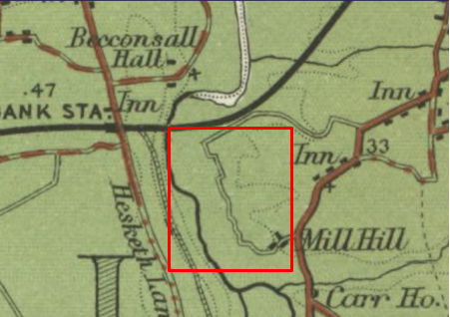

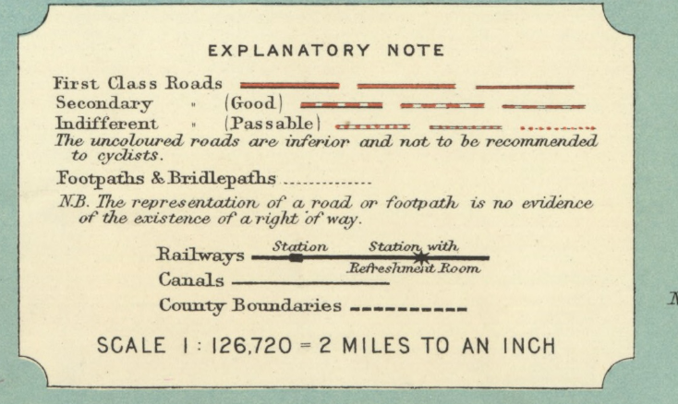
Published 1905
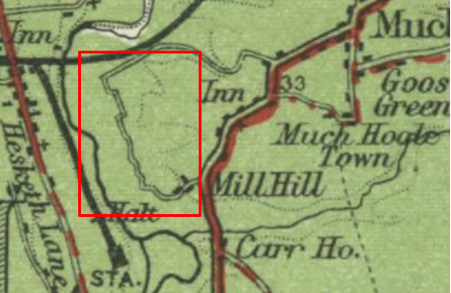
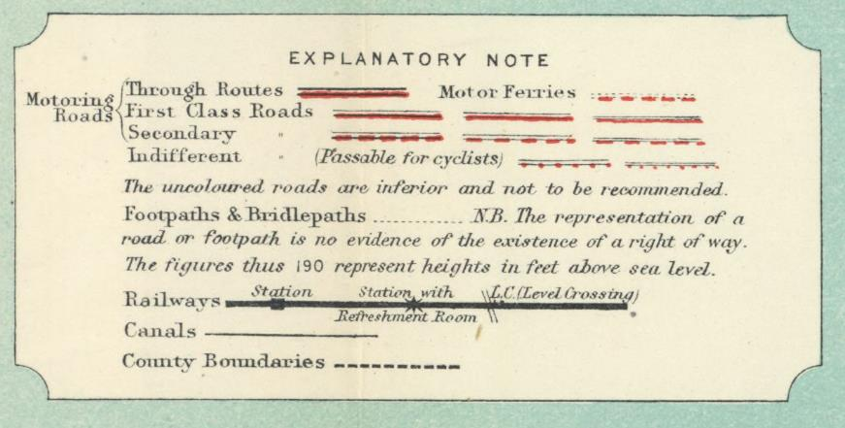
Published 1920

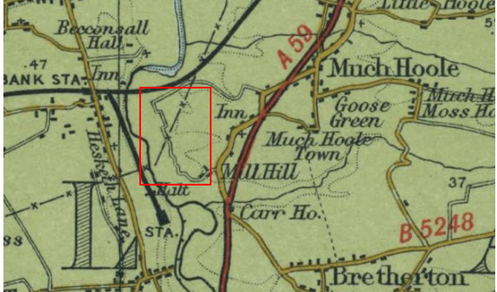
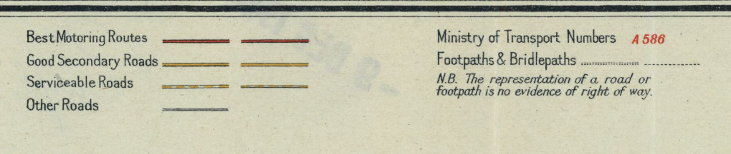
Published 1941
Observations |  | The application route is shown on all three maps as part of a an uncoloured (inferior) or 'other road'. Of significance is the fact that Haunders Lane (a public vehicular road) which ran parallel to the application route in a more direct north - south line was not shown on any of the three map editions but the application route was shown.
Investigating Officer's Comments |  | OS maps dated before and after the publication of Bartholomew's Maps confirm the physical existence of the application route and Haunders Lane over this period. As Bartholomew's Maps were derived from the Ordnance Survey maps of that time Haunders Lane may have been purposely omitted by Bartholomew at that time suggesting that the application route was the more significant route at that time and was capable of being used and considered to be a public vehicular road – albeit of inferior standard to those more widely recommended for use.
Finance Act 1910 Map | 1910 | The comprehensive survey carried out for the Finance Act 1910, later repealed, was for the purposes of land valuation not recording public rights of way but can often provide very good evidence. Making a false claim for a deduction was an offence although a deduction did not have to be claimed so although there was a financial incentive a public right of way did not have to be admitted.  Maps, valuation books and field books produced under the requirements of the 1910 Finance Act have been examined. The Act required all land in private ownership to be recorded so that it could be valued and the owner taxed on any incremental value if the land was subsequently sold. The maps show land divided into parcels on which tax was levied, and accompanying valuation books provide details of the value of each parcel of land, along with the name of the owner and tenant (where applicable).  An owner of land could claim a reduction in tax if his land was crossed by a public right of way and this can be found in the relevant valuation book. However, the exact route of the right of way was not recorded in the book or on the accompanying map. Where only one path was shown by the Ordnance Survey through the landholding, it is likely that the path shown is the one referred to, but we cannot be certain. In the case where many paths are shown, it is not possible to know which path or paths the valuation book entry refers to. It should also be noted that if no reduction was claimed this does not necessarily mean that no right of way existed.
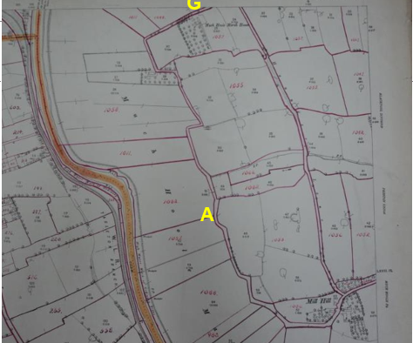

Observations |  | The full length of the application route is shown excluded from the numbered plots in the same way that Mill Hill Farm and Haunders Lane are excluded.
Investigating Officer's Comments |  | The map prepared under the provisions of 1910 Finance Act shows the whole of the route excluded from adjacent land in private ownership. The Act required all land in private ownership to be recorded so that it could be valued and the owner taxed on any incremental value if the land was subsequently sold. The maps show land divided into parcels on which tax was levied, and the accompanying valuation books provide details of the value of each parcel of land, along with the name of the owner and tenant (where applicable). The Instruction No. 560 to the surveyors said that the parcels ‘should continue to be exclusive of the site of the external roadways’. It is advised that roadways were said to be routes ‘subject to the rights of the public’ and therefore exclusion of a route may indicate that public use was known but not necessarily vehicular status. Whilst there may be other reasons for a route to be excluded – notably cases of private roads set out in Inclosure Awards with no assigned landownership - but in this instance there is no evidence to suggest that the route derived from the Inclosure process, indicating that the route’s status was more likely than not excluded because it was considered to be public.  In this instance therefore the exclusion of the route from the taxable hereditaments is good evidence of, but not conclusive of, public carriageway rights.
25 Inch OS Map  LXVIII.14 | 1931 | Further edition of 25 inch map, surveyed 1891-1892, revised in 1929 and published in1931.
Observations |  | The application route is shown as it is on the earlier 25 inch OS maps.
Investigating Officer's Comments |  | The application route existed as a substantial route in 1929 and appeared to be capable of being used by horses and vehicles.
Authentic Map Directory of South Lancashire by Geographia | Circa1934 | An independently produced A-Z atlas of Central and South Lancashire published to meet the demand for such a large-scale, detailed street map in the area. The Atlas consisted of a large-scale coloured street plan of South Lancashire and included a complete index to streets which includes every 'thoroughfare' named on the map.  The introduction to the atlas states that the publishers gratefully acknowledge the assistance of the various municipal and district surveyors who helped incorporate all new street and trunk roads. The scale selected had enabled them to name 'all but the small, less-important thoroughfares'.
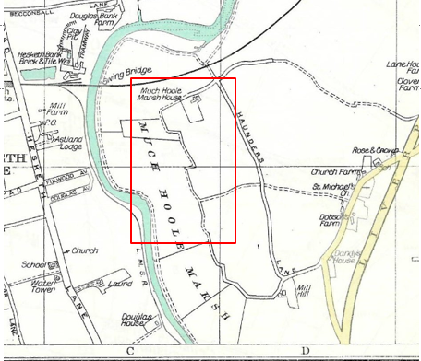
Observations |  | The full length of the application route was shown.
Investigating Officer's Comments |  | The application route is shown in the atlas consistent with how other nearby routes of various status' are shown. No inference can be made.
Aerial Photograph | 1940s | The earliest set of aerial photographs available was taken just after the Second World War in the 1940s and can be viewed on GIS. The clarity is generally very variable.
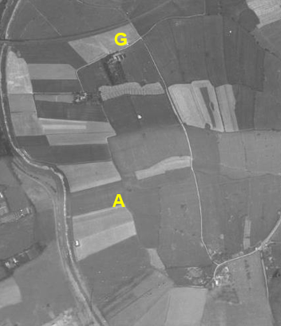
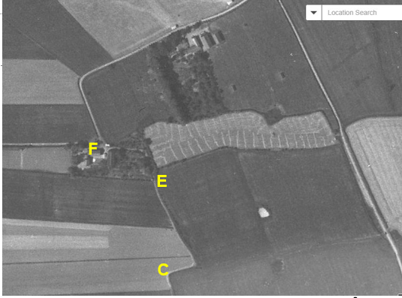
Observations |  | The application route can be seen on the photograph consistent with how it was shown on the OS maps considered above. From point A the route does not appear to be heavily used – particularly by vehicles and gives the appearance of a route more likely to have been used at that time on foot and possibly on horseback and farm machinery through to point C from where it is more clearly visible through to point G. Haunders Lane running in a straight line to the east of the application route is far more visible suggesting more visible suggesting that it was the route used predominately by vehicular traffic by the 1940s.
Investigating Officer's Comments |  | It is not possible to determine from the aerial photograph whether the full length of the route was passable in the 1940s.  However, the surface is not clearly visible along the full length suggesting that use of much of its use by the 1940s may have been on foot or possibly on horseback together with low levels of use by farm vehicles and suggesting that other use had declined.
1:25000 OS Map  34/42 - 15046 | 1946 | Small-scale OS submitted by the applicant.
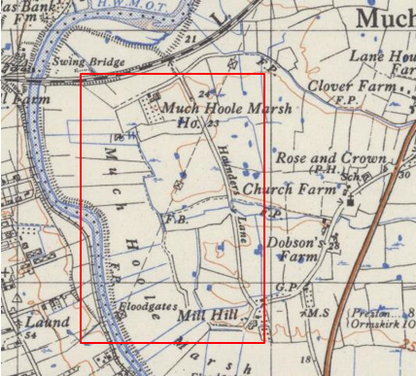
Observations |  | The full length of the application route is shown but appears to be less significant than on earlier maps examined. Use as a through route by vehicles may have declined from the past as supported by the 1940s aerial photograph.
Investigating Officer's Comments |  | The full length of the application route existed and appeared to be capable of being used.
6 Inch OS Map  Sheet 42SE | 1955 | The OS base map for the Definitive Map, First Review, was published in 1955 at a scale of 6 inches to 1 mile (1:10,560). This map was revised before 1930 and is probably based on the same survey as the 1930s 25-inch map.
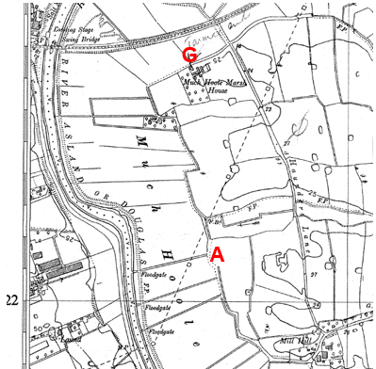
Observations |  | The application route is shown consistent with how it is shown on other OS maps at this scale. The origin of the handwritten note indicating that the route was tarmac up to point I is unknown.
Investigating Officer's Comments |  | The application route existed in the 1930s and appeared to be wide enough to be used.
1:2500 OS Map  SD 45 22 | 1963 | Further edition of 25 inch map reconstituted from former County Series and revised in 1962 and published 1963 as National Grid Series.
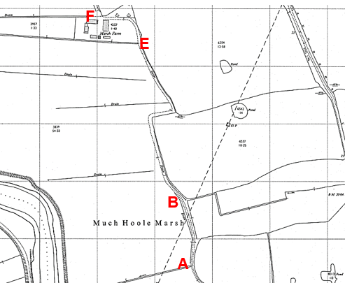

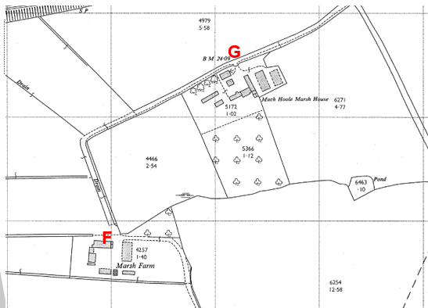
Observations |  | The application route is shown consistent with how it is shown on other OS maps at this scale.
Investigating Officer's Comments |  | The application route existed in the 1960s and appeared to be capable of being used.
1:25, 000 Map  SD 42 | 1968 | Revised 1967 and reprinted 1968.
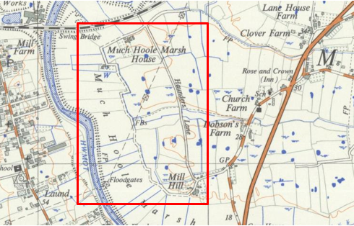
Observations |  | A further small-scale OS map showing the application route as being part of a substantial through route suggestive of a route capable of being used at least on horseback.
Investigating Officer's Comments |  | The application route is shown to have existed physically but no inference can be drawn regarding public rights.
1 inch OS  Preston Sheet 94 | 1969 | 1 inch OS map made and published 1961 and reprinted 1969.
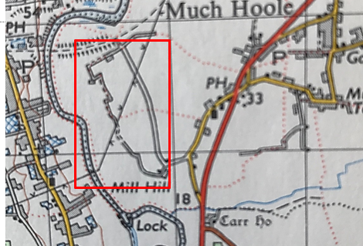
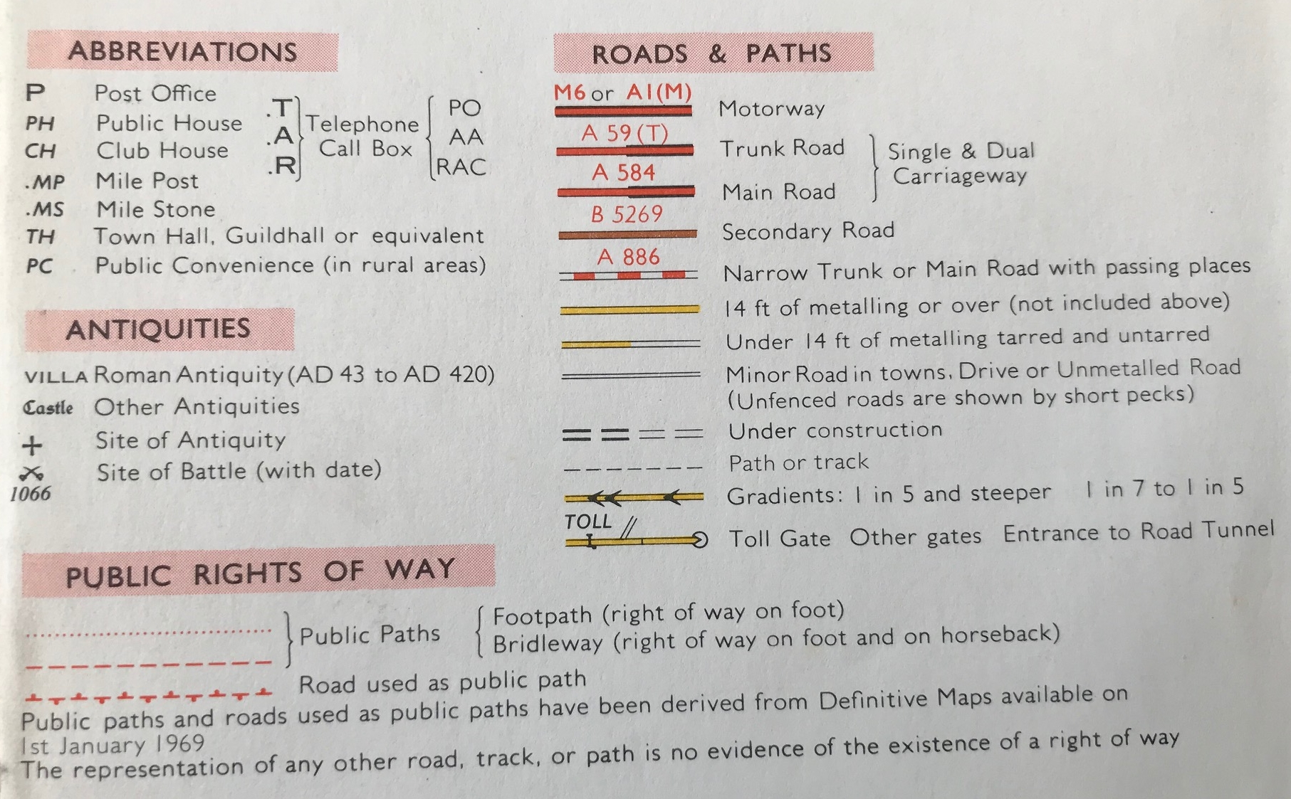
Observations |  | This small-scale OS map shows the full length of the application route as an unmetalled and partially unfenced route.
Investigating Officer's Comments |  | The 189 OS map sheets in this 1 inch map series are described by the OS as giving a detailed topographical picture of the country. The maps are described by the OS as showing 'virtually all roads' with colours used to indicate road classification, types of surface and width. The sheets were regularly revised and important road changes added whenever a sheet was reprinted. The fact that the application route is shown on the map therefore suggests a route of a substantial nature which appeared capable of being used at least on horseback.
Aerial photograph | 1960s | The black and white aerial photograph taken in the 1960s and available to view on GIS.
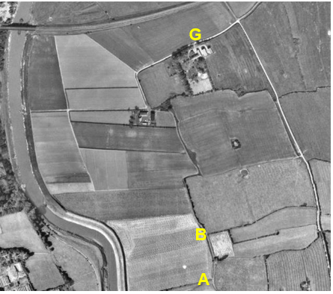
Observations |  | The application route can be seen on the photograph. It is more visible than it was on the 1940s photograph but not as wide or visible as the public vehicular routes to which it connects.
Investigating Officer's Comments |  | No inference can be made with regards to the existence of public rights but the aerial photograph supports the existence of the route in the 1960s.The fact that it is more visible than it was in the 1940s may be because of an increase in vehicular use again. It appears highly unlikely that the route, having seen a decline in use, had been surfaced to make it suitable for modern day traffic but the way that it appears in the 1960s would be consistent with the increased use of mechanical farm machinery which could then use the route to access the adjoining fields.
Aerial Photographs | 2000-2017 | Aerial photographs submitted by a landowner objecting to the application.
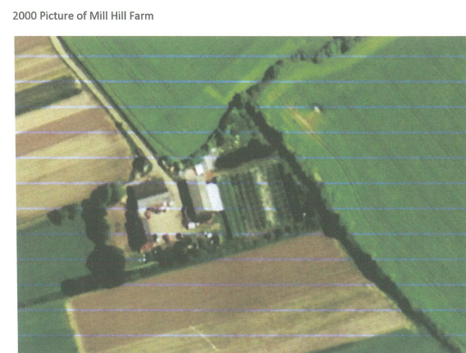

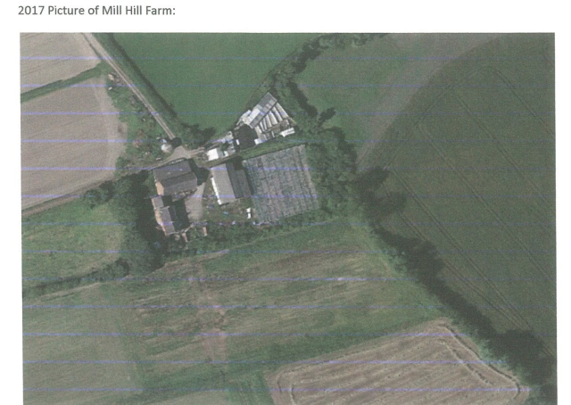
Observations |  | The two photographs were submitted by a landowner to illustrate lack of use of the footpath. The photographs are incorrectly labelled as being pictures of Mill Hill Farm but are actually of Marsh House and cover the area crossed by the application route leading from point D towards point E and then through the farm to point F and then part of the access road to and from the farm leading to Hannings Farm at point G.  Neither photograph shows a track consistent with the application route leading from point D to point E and then through to point F.
Investigating Officer's Comments |  | The photographs suggest little or no use of the route in 2000 and 2017. Lack of use would not remove any existing public rights.
Photograph of sign submitted by a landowner | undated | Photograph submitted by a landowner considered by them to show that the landowners had no intention of dedicating the route.
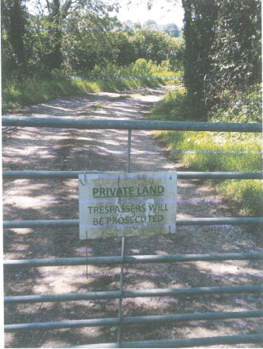
Observations |  | The photograph shows a sign that is attached to a gate across Mill Hill Farm (U3142) south of the application route. When the application roue was inspected by the Investigating Officer in 2021 the sign was still in existence attached to the gate and the gate was open. The gate is not on the application route but is on the unclassified county road leading to point A.
Investigating Officer's Comments |  | The sign may certainly deter any modern use of the application route but no 'modern' user evidence is being considered as part of this investigation. It also indicates that the landowner at the time the sign was in place did not intend to dedicate public rights. However, the sign does not remove or negate any existing public rights and its existence on the U3142 – to which there is a public right of access - will be reported to the County Council's Highways team for appropriate action.
Definitive Map Records |  | The National Parks and Access to the Countryside Act 1949 required the County Council to prepare a Definitive Map and Statement of Public Rights of Way.  Records were searched in the Lancashire Records Office to find any correspondence concerning the preparation of the Definitive Map in the early 1950s.
Parish Survey Map | 1950-1952 | The initial survey of public rights of way was carried out by the parish council in those areas formerly comprising a rural district council area and by an urban district or municipal borough council in their respective areas. Following completion of the survey the maps and schedules were submitted to the County Council. In the case of municipal boroughs and urban districts the map and schedule produced, was used, without alteration, as the Draft Map and Statement. In the case of parish council survey maps, the information contained therein was reproduced by the County Council on maps covering the whole of a rural district council area. Survey cards, often containing considerable detail exist for most parishes but not for unparished areas.
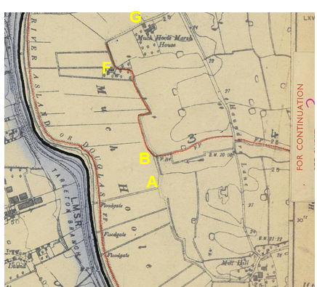

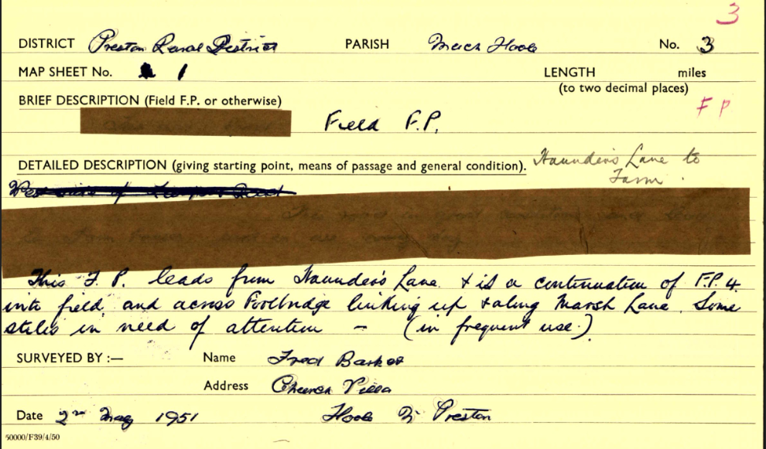
Observations |  | The application route between point A and point B is not shown on the parish survey map. In addition, part of the route leading from Marsh Farm to Haunders Lane from point F is also not recorded.  From point B through to the access road leading from Marsh Farm to Haunders Lane at point G the route is recorded as Footpath 3.  The Parish survey card records Footpath 3 as crossing fields from Haunders Lane and 'linking up and following' a route referred to as 'Marsh Lane' which, by reference to the plan, must be the application route from point B at least through to Marsh Farm at point F.
Draft Map |  | The parish survey map and cards for Much Hoole were handed to Lancashire County Council who then considered the information and prepared the Draft Map and Statement.  The Draft Maps were given a “relevant date” (1st January 1953) and notice was published that the draft map for Lancashire had been prepared. The draft map was placed on deposit for a minimum period of 4 months on 1st January 1955 for the public, including landowners, to inspect them and report any omissions or other mistakes. Hearings were held into these objections, and recommendations made to accept or reject them on the evidence presented.
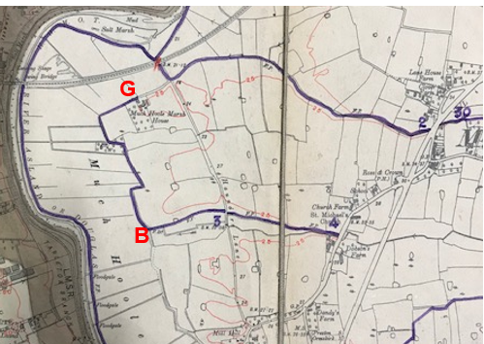
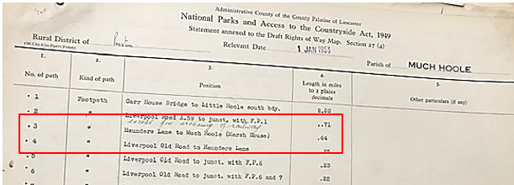
Observations |  | The application route from point B to point G is shown as part of Footpath 3 which is described in the Draft Statement as being from Haunders Lane to Much Hoole (Marsh Farm). The route of the footpath is shown as having been extended through to point G since it was originally drawn on the Parish Survey Map. The application route between point A and point B is not shown and there were no representations or objections to what was shown or omitted.
Provisional Map |  | Once all representations relating to the publication of the draft map were resolved, the amended Draft Map became the Provisional Map which was published in 1960, and was available for 28 days for inspection. At this stage, only landowners, lessees and tenants could apply for amendments to the map, but the public could not. Objections by this stage had to be made to the Crown Court.
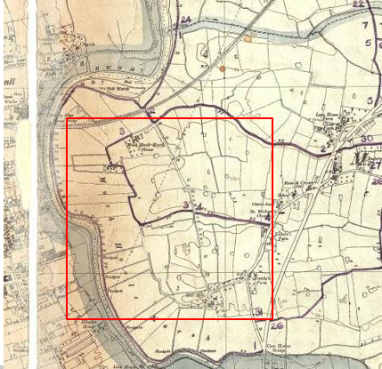
Observations |  | The application route between point A and point Bis not shown on the map. The application route between point B and point G is recorded as a public footpath and no representations or objections were made.
The First Definitive Map and Statement |  | The Provisional Map, as amended, was published as the Definitive Map in 1962.
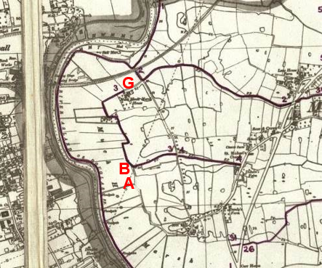

Observations |  | The application route between point A and point B is not shown. The application route between point B and point G is recorded as Footpath 3.
Revised Definitive Map of Public Rights of Way (First Review) |  | Legislation required that the Definitive Map be reviewed, and legal changes such as diversion orders, extinguishment orders and creation orders be incorporated into a Definitive Map First Review. On 25th April 1975 (except in small areas of the County) the Revised Definitive Map of Public Rights of Way (First Review) was published with a relevant date of 1st September 1966. No further reviews of the Definitive Map have been carried out. However, since the coming into operation of the Wildlife and Countryside Act 1981, the Definitive Map has been subject to a continuous review process.
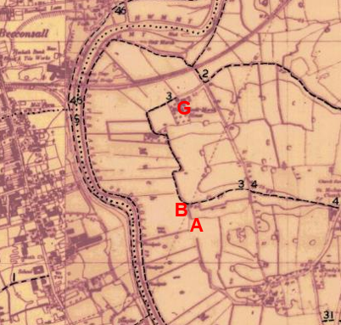
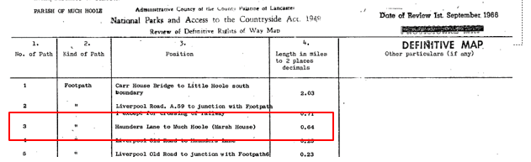
Observations |  | The application route between point A and point B is not shown. The application route between point B and point G is recorded as Footpath 3.
Investigating Officer's Comments |  | From 1953 through to 1975 there is no indication that the application route between points A-B was considered to be a public right of way which should be recorded on the Definitive Map by the Surveying Authority whereas the application route between point B and point G was considered to be a public footpath. There were no objections or representations made regarding the route from the public when the maps were placed on deposit for inspection at any stage of the preparation of the Definitive Map.
Highway Adoption Records including maps derived from the '1929 Handover Maps' | 1929 to present day | In 1929 the responsibility for district highways passed from district and borough councils to the County Council. For the purposes of the transfer, public highway 'handover' maps were drawn up to identify all of the public highways within the county. These were based on existing Ordnance Survey maps and edited to mark those routes that were public. However, they suffered from several flaws – most particularly, if a right of way was not surfaced it was often not recorded.  A right of way marked on the map is good evidence but many public highways that existed both before and after the handover are not marked. In addition, the handover maps did not have the benefit of any sort of public consultation or scrutiny which may have picked up mistakes or omissions.  The County Council is now required to maintain, under section 31 of the Highways Act 1980, an up to date List of Streets showing which 'streets' are maintained at the public's expense. Whether a road is maintainable at public expense or not does not determine whether it is a highway or not.
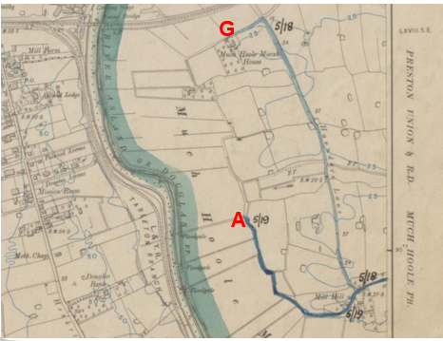
Preston Rural District Council Handover/Road Transfer Maps (above)
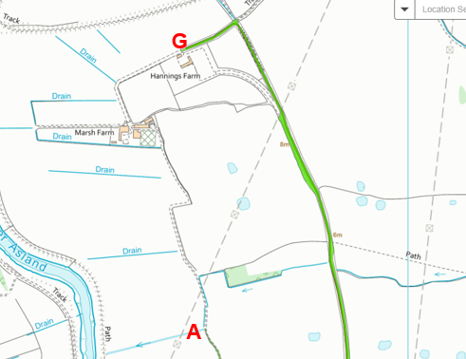
Lancashire County Council highway adoption records
Observations |  | The application route is not recorded as being a publicly maintainable highway (other than as a public footpath from point B to point G).
Investigating Officer's Comments |  | The fact that the application route is not recorded as a publicly maintainable highway does not mean that it does not carry public rights of way and the fact that only footpath rights were recorded between points B and G does not preclude the existence of other rights.
Highway Stopping Up Orders | 1835 - 2014 | Details of diversion and stopping up orders made by the Justices of the Peace and later by the Magistrates Court are held at the County Records Office from 1835 through to the 1960s. Further records held at the County Records Office contain highway orders made by Districts and the County Council since that date.
Observations |  | No legal orders relating to the creation, diversion or extinguishment of public rights have been found.
Investigating Officer's Comments |  | If public rights – or higher public rights - are found to exist along the application route they do not appear to have been subsequently diverted or extinguished by a legal order.
Statutory deposit and declaration made under section 31(6) Highways Act 1980 |  | The owner of land may at any time deposit with the County Council a map and statement indicating what (if any) ways over the land he admits to having been dedicated as highways. A statutory declaration may then be made by that landowner or by his successors in title within ten years from the date of the deposit (or within ten years from the date on which any previous declaration was last lodged) affording protection to a landowner against a claim being made for a public right of way on the basis of future use (always provided that there is no other evidence of an intention to dedicate a public right of way).  Depositing a map, statement and declaration does not take away any rights which have already been established through past use. However, depositing the documents will immediately fix a point at which any unacknowledged rights are brought into question. The onus will then be on anyone claiming that a right of way exists to demonstrate that it has already been established. Under deemed statutory dedication the 20 year period would thus be counted back from the date of the declaration (or from any earlier act that effectively brought the status of the route into question).
Observations |  | No Highways Act 1980 Section 31(6) deposits have been lodged with the county council for the area over which the route under investigation runs.
Investigating Officer's Comments |  | There is no indication by the landowners under this provision of non-intention to dedicate public rights of way over their land.

The affected land is not designated as access land under the Countryside and Rights of Way Act 2000 and is not registered common land.

The Natural Environment and Rural Communities Act 2006

This Act effected a blanket extinguishment of unrecorded public rights for mechanically propelled vehicles (MPVs) with certain exceptions. Prior to this carriageway rights did not discriminate between vehicles which were mechanically propelled, such as cars and motorbikes, and those which were not, such as bicycles, wheelbarrows, horse-drawn carriages, donkey carts, etc.. If Committee concludes that the evidence shows that, on the balance of probability, public carriageway rights exist on the route it is then necessary to consider whether the Natural Environment and Rural Communities Act 2006 has extinguished public rights for MPVs.

Section A-B is not recorded as a public right of way on the Definitive Map and Statement and section B-G was, at the time of the Act recorded as a public footpath and we have no evidence that any other of the other exemptions apply. Therefore, in the event that public carriageway rights are shown to exist the appropriate status for the application route to be recorded on the Definitive Map and Statement would be restricted byway, with public rights for non-mechanically propelled vehicles, horses or on foot.

Summary

This investigation has been carried out based entirely on historical map and documentary evidence with no modern user evidence submitted.

As with most cases investigated, there is no single piece of map or documentary evidence which stands alone to confirm the public legal status of the route.

In this particular case the early commercial maps do not show the application route.
The full length of the application route is shown on the small-scale Old Series Cassini map which is significant as these maps were reproduced from the OS First Edition 1 inch maps and suggests that a substantial through route existed along the application route by the mid-1800s which would appear to have been capable of being used although it does not indicate whether such use was public or private.

The route is consistently shown on all OS maps examined – including those at a small-scale. In the early 1900s it was shown excluded from the Finance Act taxation process consistent with the view that it was a public highway – most probably vehicular and is shown on all three editions of Bartholomew's maps as a minor through route whilst Haunders Lane (a public vehicular route) was not shown.

Of particular interest is the fact that the route passes through farmland and was partly unenclosed yet remained largely unaltered and when Marsh Farm was built adjacent to the route at point H the route remained unaltered with the buildings positioned along either side of the route but not interfering with it in any way.

Whilst it would appear that the route would be predominantly used for agricultural purposes both in the past and in more recent times it is a through route and does provide access to and past a number of properties and connect to public vehicular highways. Whilst it is perhaps not an obvious through route for the public connecting to places of interest it does appear that it is a route of some antiquity and that it was considered to be and used in the past as a public through route.

Head of Service – Legal and Democratic Services Observations

Landownership

The majority of the length of the application route crosses land which is unregistered, A short section at the very northern end is within title LAN162796 which is the registration of a caution referring to the owner being a Mr Holden since 1982 and held for a partnership.

Information from the Applicant

The application submitted was based entirely on map and documentary evidence.

The applicant submitted copies of the following documents in support of their application:

Hennet's Map of Lancashire 1829
Extract of the 6inch OS map published 1848
25 inch OS map LXVIII.14 published 1896, 1911 and 1931
1 inch OS map published 1896
Bartholomews ½ inch map published 1904
1:25 ))) OS maps published 1955 and 1968
1 inch OS 7th Series Map of Preston published 1961
Finance Act Map ref IR 133/5/79
Tithe Map of Much Hole 1841

All maps and documents submitted have been considered earlier in this report.

Information from Others

Residents of a property on Liverpool Old Road object to the application on the basis that having been residents in the area for over 60 years the bridleway would not add any enjoyment to the public or to residents of the area.

The owner of another property on Liverpool Old Road explained that they had been a resident in the area for over 20 years and had no knowledge of the route being used as a bridleway and considered that a bridleway would not add to the enjoyment of residents of the area or the public.

A representative of Cape Limited – who own land adjacent to the route – explained that he had lived in the area for over 40 years and had no knowledge of the route being used for over 40 years and that there was no intention to dedicate the route. He considered that the bridleway would serve no purpose to the public or to local residents.

The owner of another property on Liverpool Old Road objected to the application and explained that they had lived in the area for 50 years and had not seen horses using it. They considered that there was no benefit of 'making the route a bridleway' to the public or local residents.

Information from the Adjoining Landowners

The owners of Hannings Farm object to the application on the basis that the route has never been used as a bridleway. They submitted aerial photographs from 2000 and 2017 which they considered illustrated the lack of use of the route and the fact that there was no need for a bridleway and referred to the sign on the gate near Mill Hill which stated that the land was private and that trespassers would be prosecuted indicated that there was no intention to dedicate it as a bridleway.

The owner of Marsh Farm explained that they had been a resident in the area for over 50 years and had no knowledge of the route being used for anything more than its 'specified purpose'. They considered that a bridleway would not add to the enjoyment of residents of the area or the public.

A further landowner stated that he did not consider that there was sufficient evidence to make an order and that there was no evidence of use of the route as a bridleway for 20 years or more and no real evidence a bridleway existed in the past. In addition, he raised a number of practical concerns about the fact that the route was regularly used by large farm machinery which would conflict with use on horseback and bicycle and was concerned about safety. He also considered that if an order was made this would set a precedent for further applications for routes to be recorded along private tracks.

Acland Bracewell Land Agents objected on behalf of one of the landowners affected by the application (Lilford 2005 Limited). They stated that the route had not been used by horses and that use of the land was restricted to agricultural use and is the principal route used by large farm machinery to gain access to the adjacent fields. They considered the route to be entirely unsuitable for use on horseback or bicycle due to the fact that it passed right through Marsh Farm which was a working farm which also had a licence to breed dogs, that the route was used by farm machinery, was narrow with blind bends in places and because of the potential impact on ground nesting birds.

Assessment of the Evidence

The Law - See Annex 'A'

In support of Making an Orders:
Map and other documentary evidence
No particular evidence against

Conclusion

It is advised that there is no express dedication in this matter, Committee should therefore consider, on balance, whether there is sufficient evidence from which to have dedication inferred at common law from all the circumstances or for the criteria in S31 Highways Act 1980 for a deemed dedication to be satisfied

Looking at deemed dedication under S31 Highways Act 1980, Committee will be aware that in order to satisfy the criteria for S31, there must be sufficient evidence of use of the claimed route by the public, as of right and without interruption, over the twenty year period immediately prior to its status being brought into question, in order to raise a presumption of dedication. This presumption may be rebutted if there is sufficient evidence that there was no intention on the part of the landowner during this period to dedicate the route as a public right of way.

Committee will note that there is no user evidence for this matter, rather that the evidence is of a historical vehicular highway which came into existence over 150 years ago.

Looking at whether dedication can be inferred on balance at common law, Committee is advised to consider whether the evidence presented within this report of the various map and documentary evidence does, on balance, indicate that the route was dedicated to public use and used by the public.

From the information above in the report it is suggested that Committee has sufficient evidence on balance that the route was a historical public route available as a vehicular highway which at present is recorded as a Footpath in respect of points B-G and unrecorded in respect of points A-B on the Definitive Map and Statement.

The fact that part the application route is not presently recorded as any publicly maintainable highway does not mean that it does not carry public rights of way and the fact that only footpath rights were recorded between points B and G does not preclude the existence of other higher rights.

There is no evidence that a legal stopping up of any part of the route has ever taken place.

There are points made about signage and modern user however, the gate and sign indicating "Private land" are on a public vehicular highway leading to point A not on the application route A-G.

It is advised that lack of use in more recent decades would not remove any existing public rights. The legal maxim "Once a highway always a highway " would apply as unless stopped up by proper legal process a highway remains where it was dedicated even if no longer used.

"Mere disuse of a highway cannot deprive the public of their rights. Where there has once been a highway no length of time during which it may not have been used will preclude the public from resuming the exercise of the right to use it if and when they think proper." (Harvey v Truro RDC 1903 2 Ch 638)

The suitability or otherwise of the route for horses and/or cyclists is not something that can be taken into account if highway rights are shown to exist. It will be addressed should Committee decide to make an Order and that Order be confirmed.

If Committee is content that there is sufficient evidence of an old vehicular highway between point A-G the Natural Environment and Rural Communities Act 2006 will have extinguished modern mechanically propelled rights leaving the route to be appropriately recorded as a restricted byway.

If Committee is satisfied the map and other documentary evidence is in itself considered sufficient that the route was a historical public highway, it is therefore suggested to Committee that inferred dedication can on balance be satisfied.

In conclusion, it is advised that there is sufficient evidence from which to infer a vehicular highway was already dedicated on this route many many decades ago and Committee may consider it appropriate that an Order be made for the route marked A-B to be added to the Definitive Map and Statement as a restricted byway and for the route marked B-G to be upgraded from a footpath to restricted byway on the Definitive Map and Statement and that the evidence is sufficiently strong to decide that the Order be promoted to confirmation.

Risk management

Consideration has been given to the risk management implications associated with this claim. The Committee is advised that the decision taken must be based solely on the evidence contained within the report, and on the guidance contained both in the report and within Annex 'A' included in the Agenda Papers. Provided any decision is taken strictly in accordance with the above then there is no significant risks associated with the decision making process.

Local Government (Access to Information) Act 1985

List of Background Papers

Paper | Date | Contact/Directorate/Tel
All documents on File Ref: 804-625 |  | Simon Moore, 01772 531280, County Secretary and Solicitors Group
Reason for inclusion in Part II, if appropriate

N/A

The Ordnance Survey (OS) has produced topographic maps at different scales (historically one inch to one mile, six inches to one mile and 1:2500 scale which is approximately 25 inches to one mile). Ordnance Survey mapping began in Lancashire in the late 1830s with the 6-inch maps being published in the 1840s. The large scale 25-inch maps which were first published in the 1890s provide good evidence of the position of routes at the time of survey and of the position of buildings and other structures. They generally do not provide evidence of the legal status of routes, and carry a disclaimer that the depiction of a path or track is no evidence of the existence of a public right of way.
Aerial photographs can show the existence of paths and tracks, especially across open areas, and changes to buildings and field boundaries for example. Sometimes it is not possible to enlarge the photos and retain their clarity, and there can also be problems with trees and shadows obscuring relevant features.

